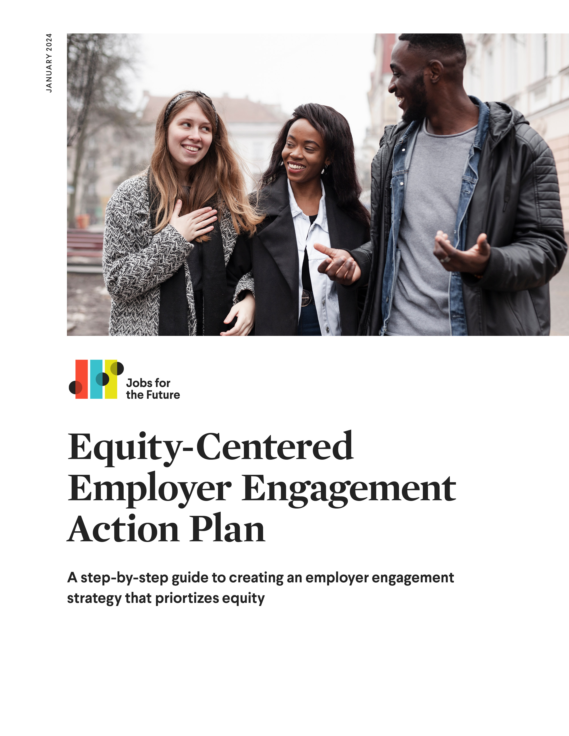

First things first
This action plan is created for institution (click to type) by person (click to type) on . Our goal is to complete each of these steps by date/timeframe (click to type) to ensure that equity is at the center of our employer engagement strategy.

Step 1: Build an Equitable Employer
Engagement Infrastructure
Answer prompts:
- What data does your college currently collect that could inform equitable employer engagement goals? What data is missing, and how might your college go about collecting it?
- Based on current data, identify a few areas where the college might be falling short of its goals to engage employers in service to equitable learner success. What kinds of SMARTIE goals might help drive equitable employer engagement progress? How might these efforts advance the DEI activities at your institution?
- Create a draft budget covering the staffing, materials, and activities you will need to achieve your SMARTIE goals. How might you go about securing additional funding for equitable employer engagement?
- Make a list of students, alumni, faculty, staff, administrators, and board members that may have access to employer connections. How might you align messaging and outreach processes across stakeholders for a more coordinated and strategic engagement approach?

The table below may be useful for identifying where employer
relationships reside within the college.
Name of department, board member, student, or alumni | Relationship with employers | Data that is collected | Where that data is housed
Click or tap here to enter text. | Click or tap here to enter text. | Click or tap here to enter text. | Click or tap here to enter text.
Click or tap here to enter text. | Click or tap here to enter text. | Click or tap here to enter text. | Click or tap here to enter text.
Click or tap here to enter text. | Click or tap here to enter text. | Click or tap here to enter text. | Click or tap here to enter text.
Click or tap here to enter text. | Click or tap here to enter text. | Click or tap here to enter text. | Click or tap here to enter text.
Click or tap here to enter text. | Click or tap here to enter text. | Click or tap here to enter text. | Click or tap here to enter text.

Step 2: Develop Partnerships with Impact Employers
Review JFF’s Impact Employer Framework. What employer partnerships currently exist that exhibit the characteristics of impact employers?
- What might be your college’s bilateral value proposition for building partnerships with impact employers?
- What current partnerships, events, and industry association memberships can you leverage to generate impact employer leads?
- What information does your college need from a discovery meeting to determine whether a company can help you meet your equitable employer engagement goals? To gather this information, what questions should you ask employers?
- What kinds of equity-centered solutions might your college be able to offer employers? How can you ensure that these solutions meet student needs as well?
- What types of data will your college need to collect to track progress on your equitable employer engagement goals? How will you write data sharing into your MOUs with employers?

Click or tap here to enter text.

Step 3: Drive Impact Through
Sustained Engagement
Answer prompts:
- What partnership management practices might your college put in place to ensure that employer relationships result in sustained impact?
- What processes can your college devise for collecting, analyzing, and sharing data on SMARTIE goal progress during equitable employer engagement?
- What systemic barriers have learners at your college identified as most detrimental to their employment success? How can you create a feedback loop for input from learners and workers? How might you mobilize employers to advocate for policy change addressing these barriers?
Click or tap here to enter text.

Next steps

Remaining steps for success
Describe what your next steps are to ensure success in articulating and achieving your equity-centered employer engagement goals.
Answer prompts:
- What are your next steps?
- Whom do you need to engage?
- What is your timeline?
Click or tap here to enter text.

